
Pre-requisite for Newman
1.Download node js and install From the below link
( https://nodejs.org/en/download/prebuilt-installer )
2.Click on the Download Node.js v20.15.0(Button in green colour)
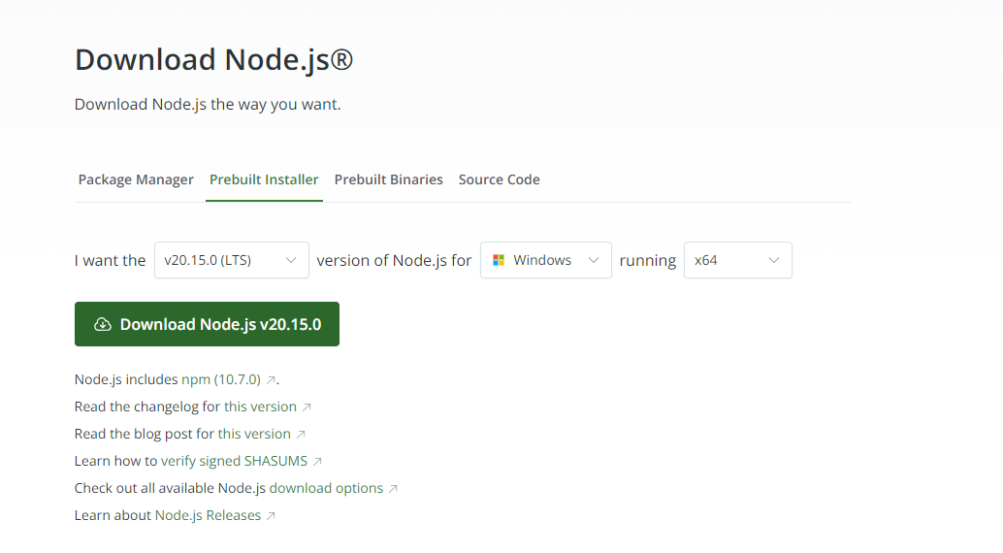
3. Type Node -v in command prompt and version of node js will be displayed
4. Type npm install -g newman in the command prompt for Newman installation
5. After installing newman ,type newman -v in the command prompt and version of newman will be displayed
6. Type npm install -g newman-reporter-htmlextra in the command prompt for hrml reporting
7. After installing html report ,type
newman-reporter-htmlextra -v in the command prompt and version will be displayed.

Steps to Jenkins Installation:
Check the Java Version :
- Open Command Prompt Type java –version and press enter.
The Jenkins.war file is a self-contained executable Java archive (WAR) file that contains the Jenkins application and all of its dependencies. It can be used to run Jenkins as a standalone application on any machine that has a Java runtime environment (JRE) installed.
Download Jenkins war file from https://www.jenkins.io/download/
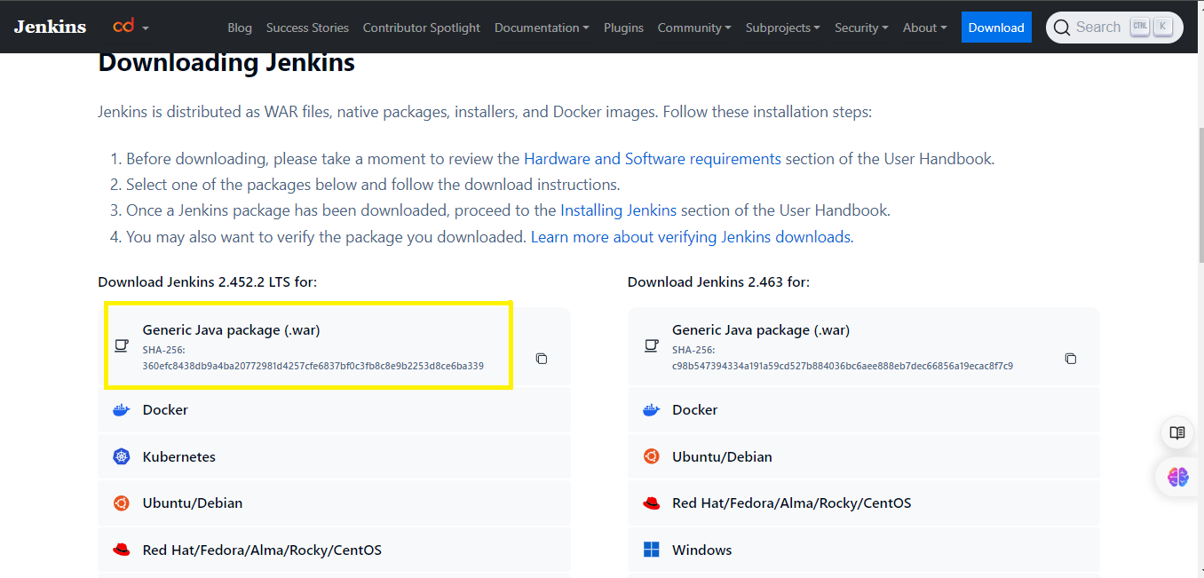

NOTE : If you are using java 8 ,pls download the jenkins from below link and proceed with the installation https://get.jenkins.io/war-stable/2.346.1/

Refer: Generic JAVA package (.war)
Run Jenkins.war
Once you have a Java runtime environment (JRE) installed, you can start Jenkins by running the following command in a terminal window from where jenkins.war is present.
Java -jar jenkins.war
Copy the key/password from command prompt
Open Jenkins
This will start the Jenkins application, and you can access the Jenkins user interface by opening a web browser and navigating to http://localhost:8080/.
If you getting java.net.BindException or any other exception ,Use below command ,

netstat -ano | findstr ":8080"
taskkill /F /PID PID(your processID)
Example
========
netstat -ano | findstr ":8080"
taskkill /F /PID 14764

- Install the required plug in
- login into jenkins and confirm.
- Use this when Jenkins is not opening in 8080, jetty error
- java -jar jenkins.war --httpPort=8081

If plug in not installed
java -jar jenkins.war --enable-future-java

If version is not supported:
Downgrade it to 17th version from below link, setup in the environment variable to fix the problem
https://www.oracle.com/java/technologies/javase-downloads.html

If you are running with higher version
java -jar jenkins.war --en

